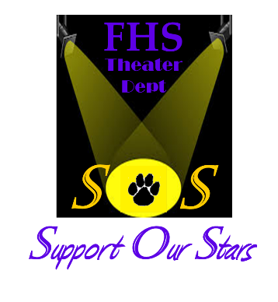
THIRD ANNUAL TRIVIA NIGHT
Saturday, October 21, 2017
Festus High School Gymnasium
501 Westwind Drive, Festus, MO 63028

Doors Open at 6:00 p.m. – Trivia Starts at 7:00 p.m.
Registration: by October 1….$80 Per Table
After October 1…$120 Per Table
$15 Per Person Partial at the Door

INCLUDES: Trivia, Table Snacks & Attendance Prizes

50/50 Drawing • Raffle Items • Silent Auction • Mulligans

Costume contest; Prizes awarded

TRIVIA TEAM REGISTRATION FORM
Send advance Registration Form and Check
(payable to: FHS Theater SOS Club)

FHS Theater SOS c/o Kay-Anne Hiller
738 Santschi Dr.
Herculaneum, MO 63048
FHSTheaterSOS@gmail.com

(Team Captain/Contact):

E-Mail Address: and Phone #

Thank you for Supporting Our Stars!

